Testing BBSEToken.sol contract

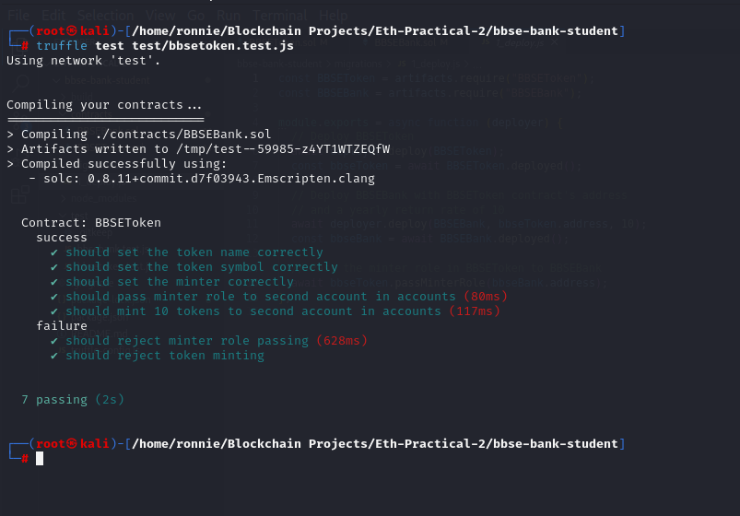

Testing BBSEBank.sol contract

Starting development network on ganache

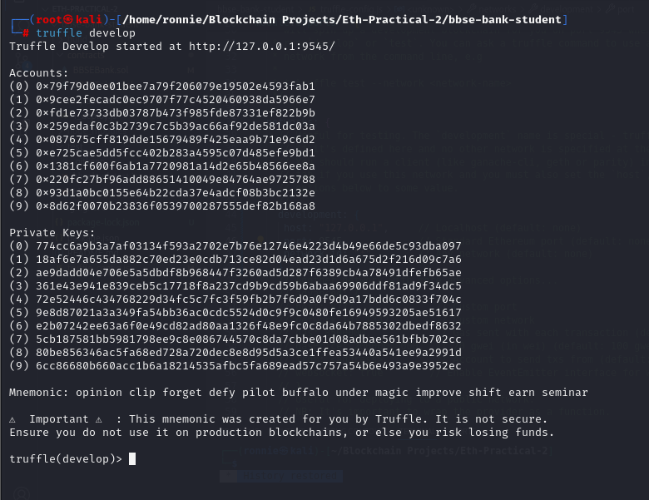

Deploying both contracts on Ganache

